First Meeting of the Year Meeting Notes
Next Meeting!
- When: Wednesday, September 25th
  - 8 – 9 pm
- Where: Centennial Hall 1400
- What: PA Panel
  - Practicing PAs from various specialties will be coming to share their experiences and answer questions from the club!
- Who: Everyone!

Introductions:
- President: Henk Boese
  - Boese2483@uwlax.edu
- Vice President: JonaLee Feller
  - Feller5713@uwlax.edu
- Secretary: Karin Hayford
  - Hayford2169@uwlax.edu
- Treasurer: Eva Snyder
  - Snyder0706@uwlax.edu
- Volunteer Coordinator: Henry Van Pietersom
  - Vanpietersom5667@uwlax.edu
- Public Relations Officer: Ava Lortscher
  - Lortscher4408@uwlax.edu
- Faculty Advisor: Faye Ellis
  - Fellis@uwlax.edu

What is a PA?
- On Wednesday, we talked about the basic role of a PA, some examples of their responsibilities, and comparisons between PAs, NPs, and MDs. We talked about fun facts such as PAs ranking as #2 in healthcare jobs, there will be a 28% growth from 2023-2033, and that the 2023 median pay was $130,000 (changes based on location and specialty). We talked briefly about PA education and how you can have any major in undergrad if you meet the prerequisites.

Fall Meeting Dates:
- September 25th (everyone)
  - PA Panel: practicing PAs talk about profession and field Q&A
- October 9th (underclassmen)
  - Josh Bench, pre-health advisor, presents on Undergraduate Timeline and Tips
- October 23rd (everyone)
  - UWL and Madison PA Admissions come to speak
- November 6th (everyone)
  - Overview of admissions requirements
- November 20th (everyone)
  - 1st Year PA Student Panel

How to become a member of the Pre-PA Club:
- Join MyOrgs
  - Username: beginning of UWL email
  - Search UWL Pre-PA club and request to join
- Pay club dues by 2nd meeting!
  - $10 for the semester or $15 for the year
  - You can bring cash to the next meeting or Venmo @UWLprepaclub
- Attend Meetings
  - Every member is allowed 2 absences per semester (1 excused, 1 unexcused)
  - Make sure to email me if you know you will be missing: uwlprepaclub@uwlax.edu
- Volunteer
  - We are doing something different this year. We highly recommend getting volunteer hours, but it is not mandatory for club membership. Volunteer hours are important for your resume, and we will continue to provide many volunteer hours through the club!
  - We are recording our club volunteer hours through UGetConnected now
    - You can find this by searching UGetConnected and logging in with your student email and password
  - We are also doing a monthly award for the member with the most volunteer hours

Apparel
- We are working on getting an apparel mockup for our next meeting on September 25th
  - Plan on T-shirt and Crew Neck options

Volunteering Opportunities:
UWL Blood Drive
- UWL is hosting a blood drive with American Red Cross. Volunteers are needed to assist with tabling before the event to raise awareness and for day-of-event support. You can also make a blood donation, as the blood supply is very low right now. You will still get volunteer hours for blood donation!
  - When: October 1st and 2nd
    - Tabling will be before these dates
  - Where: Student Union Bluffs Ballroom
    - Tabling in the Union and Whitney

Vida Volunteer Trip to Guatemala
- Travel to Guatemala with a group of UWL students to provide medical care to medically underserved communities and learn about Guatemalan culture! More information can be found by contacting the UWL Vida Ambassador Brooke Bergeron: bergeron0016@uwlax.edu or by following the QR code below!
  - When: January 10th – January 20th
  - Where: Guatemala
  - If you register from September 17th – September 30th, you can get $100 off your registration fee by using the code: VIDAB2S
    - September 30th Registration Deadline
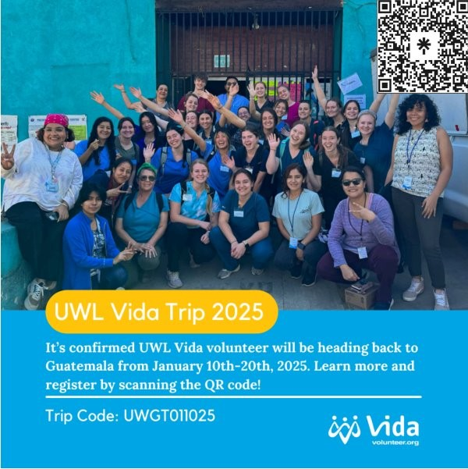

Bethany St. Joseph Bingo:
- BSJ is a local nursing home in La Crosse that allows our club to assist their residents in playing bingo. This opportunity is a fun and meaningful way for our club to get involved in the community by bringing joy to the residents. Volunteers will help bring residents to the day room and back after bingo.
- The dates are TBD but will be communicated with you all and updated on the website when they are set!

Salvation Army Volunteering:
- The UWL Pre-PA club will volunteer at the Salvation Army in La Crosse again this year. This opportunity involves serving dinner meals for those sheltering or in need of food in the La Crosse Area. This volunteer opportunity is short and sweet. You will help with set up, preparation, delivery, and clean up for the dinner hour. We are looking for two volunteers per date, so grab your friend and get your hours!
- The dates are TBD but will be communicated with you all and updated on the website when they are set!

Gunderson Health Systems:
- Gunderson Health Systems has volunteer opportunities available for students looking to get involved! This can be a great way to get health care experience outside of patient care hours. If you are interested in applying for volunteering, follow this link for their application!

St. Clare Health Mission:
- St. Clare Health Mission is a free volunteer clinic in our community to provide medical care to the underserved. Our club already has a big fundraiser with them, but they also have volunteers help at the clinic. This can be a great way to get health care experience outside of patient care hours. If you are interested in applying for volunteering, follow this link to their application!

We plan to have more information on volunteer opportunities coming soon!

Upcoming Events:
Pre-PA Mock Interview
- An important part of applying for PA programs is preparing for potential interviews. Interviews can be stressful and challenging, but they are a great way to show admissions committees who you are. The Pre-PA mock interview night is hosted by Josh Bench and will simulate a real PA interview.
  - When: Wednesday, September 18th from 7 pm – 9 pm
  - Where: 1235 Centennial Hall
  - Who: Open to Sophomores - Seniors
  - Sign up is closed, but we look forward to seeing those who have signed up!

