**PA News**

* 16 states are included in the PA licensure compact!
  + 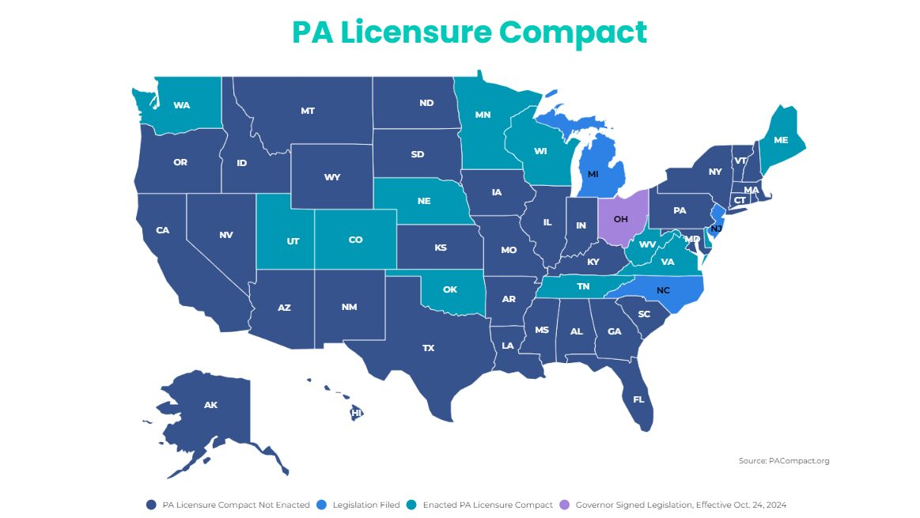
  + The compact will take effect in early 2026!
* UW Parkside is starting a PA program in 2027
* Concordia St. Paul no longer requires a 200 level stats course

**Meet Your New 2025-2026 Exec Board!**

* **President:** Zoe Kratzke
* **Vice President:** Audrey Banske
* **Secretary:** Ally Thoma
* **Treasurer:** Ally Zimmerman
* **Public Relations Coordinator:** Bella Bresnahan
* **Volunteer Coordinator:** Yariza Luna Juarez

We are done with meetings for the year! We are so grateful for your participation in making this year a success. It is bittersweet to have the Pre-PA club year come to an end. On behalf of the 2024-2025 exec team, we wish you the best of luck in your PA journey. We hope that we helped along the way and are still available for any questions you may have. Thank you for an amazing year!