**3.5.25 Meeting Note**

* **Application Basics**
  + Average number of schools people apply to
    - 8
  + Cost of application
    - $184 for first program plus $61 for each additional program
    - Some schools have a separate application fee as well
    - Other fees include
      * Official transcripts
      * Paying for standardized tests and sending test results
      * Resources that help with applications
  + Number of patient care hours recommended
    - Most competitive applicants have at least 1,000-2,000 hours
    - Depends on the program and what they emphasize
      * Ex. Bethel requires 500 hours and does not give more “points” for going over the 500, where other schools like you to have more hours
  + Gap year?
    - Taking a gap year depends on the individual
    - Maybe consider a gap year if
      * You want to get more patient care hours to be competitive
      * You want to get a year of full-time work in before you start school
      * You don’t feel ready to go right into PA school
      * You want to travel or do other experiences that you wouldn’t be able to during school
    - Taking a gap year does not necessarily change the application process, it just changes when you take it
      * No gap year: apply one year before your undergraduate graduation
      * 1 gap year: apply the spring you graduate from undergrad
      * More gap years: apply one year before you plan to start PA school
    - Application deadlines
      * Cycle opens April 24th, 2025
        + There are 10 application deadlines that depend on the program
        + All my schools had the August 1st deadline - Karin
      * Cycle closes April 1st, 2026
* **Application Timeline**
  + 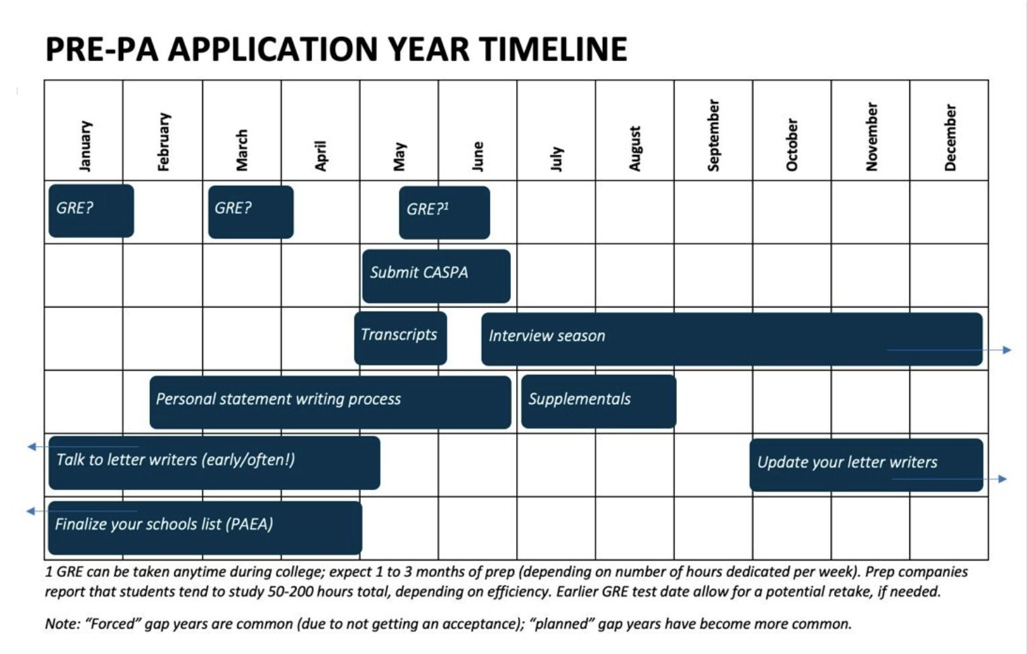
* **Researching Schools**
  + Check their websites!
    - Many schools clearly list pre-recs needed
    - What do they recommend for their own undergrad pre-PA curriculum?
  + When in doubt, send them an email!
    - Admissions staff is there to answer your questions, don’t hesitate to reach out
      * Especially with confirming that your courses fit their requirements
    - Some schools accept transfer/AP credits for pre-recs, others don’t, some accept one or the other
  + Admissions stats
    - Many schools offer admissions stats for their previous classes
  + What to consider when researching schools
    - Accreditation
    - Cost/location
    - Program length/structure
    - Clinical rotations (amount and type)
      * If they find your rotations for you
    - Class size
    - Mission statement
      * Does it fit your goals and values?
* **Letters of Recommendation**
  + Make connections with potential letter writers!
    - You can do this right now!
      * Professors, PAs that you shadow, nurse managers, etc.
  + Make sure to check program requirements
    - Most require 3 letters of rec, but may vary
    - May have specific requirements for who the letters are from
      * Academic – specifically science professors
      * Healthcare work supervisor
      * PAs from shadowing or direct patient care experiences
  + Make sure to ask letter writers early (December or January before applying)
  + Try to ask them in person or ask about the possibility in person
  + Send an email with more details that may include
    - CV or Resume
    - Description of how the process goes
    - When you need the letter by
  + Highlight what you have enjoyed and learned while working with them
  + Make sure to update your letter writers along the way!
* **Tests**
  + GRE
    - Who still requires the GRE?
      * Carrol University (WI)
      * Missouri State University
      * Chamberlain University (Chicago)
      * Trine University (Indiana)
      * Etc.
    - Check the schools you are interested in applying to and see if they still require the GRE
      * Many schools are moving away from it
    - What does the GRE entail?
      * 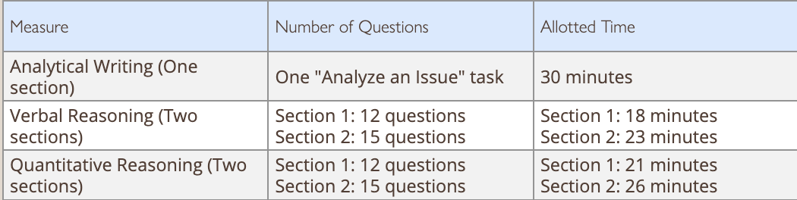
      * You DO NOT need a paid study tool online to do well
      * Many free resources online such as
        + PowerPrep Practice Tests
        + Target Test Prep
        + Study.com
  + PA-CAT
    - Not a very common requirement
      * Only 20 schools, give or take, require the PA-CAT
    - What does it entail?
      * 240-item assessment
      * 4 hours
      * $257
        + Plenty of free resources included
      * Taken in person at a testing center on a computer
    - Subjects on the PA-CAT
      * Anatomy
      * Physiology
      * General biology
      * Biochemistry
      * General and organic chemistry
      * Microbiology
      * Behavioral sciences
      * Genetics
      * Statistics
  + CASper
    - Also not a very common test, but the UWL PA program and Madison PA program do require it
    - This test is used to “measure personal and professional skills and situational judgement”
      * Open response questions, taken online on your own computer (no testing site)
        + Video responses and written responses
        + 90-110 minutes
        + $85
      * Does not require studying
        + Take in spring of your application year
        + When you sign up for the test, you will get access to a practice test so you understand the format of the exam
      * What qualities does it assess?
        + 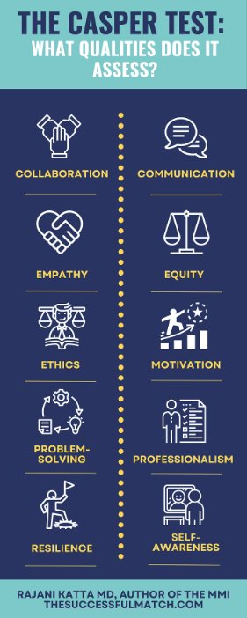
* **Personal Statement**
  + Everyone’s personal statement and process will be different
    - 5,000-character limit!
      * Roughly 800-1,000 words
      * Need to be intentional with what you include
  + Here are some of my (Karin) tips
    - Keep a list of your experiences that you can write down things that impacted you – will come in handy for writing about specific experiences you have had
    - Think of your main values or topics
      * Look at the list of experiences and line up some experiences you can use to emphasize your values/goals/topics in your paper
      * This makes the paper more personal and interesting
    - Make sure that the first three sentences grab the reader's attention and encapsulate your “why.” You should know from the first three sentences what the rest of the paper is going to be about
      * Some admissions officers do not read the whole paper, so you want to make sure your paper stands out in the first paragraph and gets the point across of why you want to be a PA
    - Don’t have too many people look at your personal statement, at the end of the day it needs to sound like you!
      * However, do have some people proof read it, especially someone who has read a lot of personal statements. This could be a pre-health advisor or someone you know who is on an admissions committee of some sort.
    - Personal statement should have 0 grammatical errors
      * Some people will throw out applications if there are grammatical errors on the personal statement or supplemental questions.
    - Keep in mind the same personal statement will be sent to all the programs you apply to
      * Most programs have supplemental questions that will cover why you want to go to that specific program
  + The Pre-Health Advisors have great advice for writing personal statements and would be wonderful resources to use if you need help with any stage in the process
* **CASPA**
  + [Helpful guide](https://paeaonline.org/wp-content/uploads/2024/02/CASPA-Applicant-Guide-24-25-FINAL.pdf)
    - Lots of good information in the guide above!
    - Set up a CASPA account and explore!
  + FAQs
    - When do I start filling out CASPA?
      * Some things transfer over from cycle to cycle, such as biographic information, but your supplemental materials will not. You should set up your account and get familiar with the CASPA system, but don’t fill out the supplemental materials until the cycle opens on April 24th.
        + Fill out CASPA the year you plan on applying, don’t need to do it earlier
      * Once the cycle opens, you can start filling everything out and putting in your letter of recommendation writers (evaluators) etc.
    - Is CASPA like the Common App?
      * Yes. You only submit one application, and it will be sent to all the schools that you selected. This also means that you must follow the earliest deadline of the programs you are applying to.
      * Try to apply as early as possible and look for if the schools have rolling admissions (they go through applications as they come in and it is beneficial to submit your application earlier before spots fill up) or if they have regular admissions (they wait until after the deadline to start looking at applications)
    - When do patient care hours stop counting?
      * You can only add patient care hours up until you submit your application
      * You can add patient care hours after you submit your application, but not all schools look at additional hours submitted after the original application
      * You cannot edit your responses once you submit your application
    - How to plug patient care hours in?
    - Timing for application
      * Want to apply as early as possible
        + Can vary for different people
        + If you want to get more patient care hours before you submit your application and you are not applying to rolling admissions schools, you can apply a little later in the cycle
      * Keep in mind, it can take up to 10 business days to get your application verified after submission to make sure everything looks good
        + Want to submit well in advance to avoid problems if there is something wrong with your application and you get it sent back to you
    - How do letters of rec get sent in?
      * Once the application opens (**April 24th**), the applicant will submit the name and contact information of their evaluators into CASPA
      * The evaluator will then get an email from [support@caspa.myliaison.com](mailto:support@caspa.myliaison.com) with a link to **Liaison Letters**.
        + The evaluator may accept, complete, or deny the evaluator request.

The applicant will be able to see the progress of the letters on CASPA

* + - * The evaluation process includes:
        + Short profile with the evaluator’s information
        + Questionnaire about how the evaluator know the applicant
        + Letter of recommendation
      * All aspects of the letter of recommendation will be completed online.
        + The letter and evaluation will be submitted through a third-party portal and will not be sent through the applicant.
    - How to answer the experience description
      * Only have 600 characters for each experience description. You have to be concise while explaining what your role was and how that impacted you. Try to incorporate more than a list of tasks you performed, try to include either how that impacted you or the ways that you were able to impact your patients.
    - How to decide volunteer hours?
      * You can choose to put things as volunteer hours or healthcare hours. It is up to you to decide what you think will benefit you the most.
* **Interviews**
  + 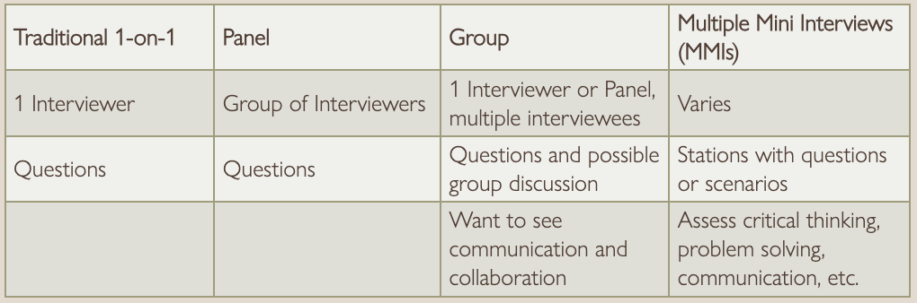
  + Mock interview night in the fall!
  + You want to prepare common questions or have experiences ready to share, but you don’t want to script too much.
    - They want to get to know you as a person!
* **If you have more questions about your application, please reach out to the club or schedule a meeting with the pre-health advisors!**